ABSTRACT

The project titled “Bharat Airlines Reservation” is a web portal developed for a brokerage company, who maintains flight details from various vendors like Air India, Emirates, Jet Airways, and British Airways etc. The objective of the system is to provide reservation and cancellation for every customer from any point to any point. The customer is given a privilege to reserve the return journey tickets at the same time of reservation.

The customer can reserve a ticket for a particular date, if seats are not available for that particular date he is kept under waiting list. To check his status confirmations he can click on confirm status. While reserving a ticket he can also check for flight details, available for that particular date.

The customer can reserve the ticket from his home PC or personally at the centers allotted. The payment can be done either through credit card. The main aim of this project is to provide user-friendly services accurately and quickly. This project is developed using HTML as GUI and JSP as middle tier and ORACLE as backend.
1. INTRODUCTION

ABOUT THE PROJECT

The project entitled “Bharat Airline Reservation” facilities to perform online booking of tickets in Bharat Airways. The project maintains the database of all flights, Flights Schedules, Customers Information for processing Online Ticket Booking In Ticket Booking.

1. SYNOPSYS:

The project Bharat Airline Reservation is designed to facilitate online reservation of airline tickets. Almost every national airlines company provides the reservation of tickets from various points in every city. No ticket can be sold to two different passengers. At the same time a passenger can reserve return journey tickets in advance. As such two vital issues, making the reservation or cancellation and flight status available cross -country and continent becomes mandatory. This portal addresses to the stated need in diligent manner.

2. PROBLEM DEFINITION

The project titled “Bharat Airlines Reservation” is a web portal developed for a brokerage company, who maintains flight details from various vendors like Air India, Emirates, Jet Airways, and British Airways etc. The objective of the system is to provide reservation and cancellation for every customer from any point to any point. The customer is given a privilege to reserve the return journey tickets at the same time of reservation.

The customer can reserve a ticket for a particular date, if seats are not available for that particular date he is kept under waiting list. To check his status confirmations he can click on confirm status. While reserving a ticket he can also check for flight details, available for that particular date.
3. EXISTING SYSTEM AND ITS DRAWBACKS
The existed system is the automation of Airline Reservation of Bharat Airways reservation of Air tickets is done through Travel Agents and Booking at airport Counters. This process is very time consuming process for customers in booking, Cancellation of tickets and getting boarding pass and ticket .

4. PROPOSED SYSTEM AND MERITS
The proposed system is to automation of Airline Reservation of Bharat Airways for online reservation of Air tickets. Customers having credit cards can register through internet and perform air reservation activities online. The Customer should be able to reserve a seat for a specific flight for a specific date. The reservation can be allowed only from 10 days prior to the date of departure. The customer can cancel an existing reservation provided with a decrease in some percentage of the amount paid by him (such as 50% return if cancelled on the due date of departure, else 25% return before the date). If the seats are filled up during the reservation process, then the customer is kept on to the waiting list, which in turn should automatically confirm.

The Payment process includes calculation of payable amount. Payment can be done either through credit card. If the customer reserves a ticket online he can pay the amount through credit card.

This system reduces the time consumption; cost incurred and also reduces the workload on counseling authority people. This system also provides user-friendly environment, which can be understand by all people. It just requires the minimum operation of the computer.

5.HARDWARE AND SOFTWARE SPECIFICATION

HARDWARE SPECIFICATIONS

Processor : Intel Pentium or more, IBM Cyrix
(Intel compatible)

Hard Disk : 20 GB hard disk

Ram : Minimum 256 ram
Recommended for data processing.

SOFTWARE SPECIFICATIONS

Operating System : Microsoft Windows XP
Programming Environment : JSP
Style Sheets : CSS
Database : Oracle
Web server : Apache Tomcat
Web browsers : Internet Explorer
Scripting language : Java Script
Database Drivers : ODBC Drivers

FEASIBILITY STUDY

All projects are feasible – given unlimited resources and infinite time! Unfortunately, the development of computer-based system or product is more likely plagued by a scarcity of resources and difficult delivery dates. It is both necessary and prudent to evaluate the feasibility of a project at the earliest possible time. Months or years of effort, thousands or millions of dollars, and untold professional embarrassment can be averted if an ill-conceived system is recognized early in the definition phase.

1. TECHNICAL FEASIBILITY:

It is technically feasible to design the project as; the entire modules described in the modules description can be created using Front-End interaction Java and back end database oracle.
Advantages of ORACLE
1.Oracle is a large database and several functional programs.
2. Oracle is a pure database software. In our project we maintain database, so we selected Oracle
3. It provides a set of functional programs that user can use as tools to build structures and perform tasks.
4. Oracle is highly sucured software.
5. Oracle contains many tools like SQL,PL/SQL etc
6. SQL is a unified non-procedural language.

2. ECONOMIC FEASIBILITY
In our project to find the cost of our project the following things are needed
Number of the persons(N)=3
Effort in person cost(E)=2000
Time period(t)=3 moths
Interface of the project(I)=10% of E
Number of modules(M)=2
Software cost(SC)=10000*5%(including OS, Front end,Back end)

Project Cost=((N*E)+(I*M)+SC)*t
=((3*2000)+((2000*0.1)*2)+(10,000*0.05)*3
=(6000+400+500)*3
=6900*3
=20,700/-
.
3. OPERATIONAL FEASIBILITY

In our application front end is developed using GUI. So it is very easy to the user to enter the necessary information. But the should have user has some knowledge on using web applications before going to use our application.

CHAPTER - 1
PROJECT ANALYSIS

PROJECT ANALYSIS

1. EXPLAIN ABOUT OUR ANALYZED CONCEPTS

Object oriented analysis is a method of analysis that examines the requirements from perspective of the classes and objects found in vocabulary of problem domain.

Analysis is the process of extracting the needs of a system and what that system must do to satisfy the client’s requirements.

DOMAIN ANALYSIS

Domain analysis is the process by which a software engineer learns background information, which helps to understand the problem. The word ‘domain’ in the case means the general field of business or technology in which the customers expect to be using the software.

REQUIREMENTS ANALYSIS

Requirements analysis is the process of defining what the user requires from the system and defining the requirements clearly and in an unambiguous state. The outcome of the requirement analysis is the software developing activities. Thus it deals with understanding the problem goals and constraints. This specification part mainly focuses on what had been found during analysis.

A requirement is a relatively short and concise piece of information, expressed as a fact. It can be written as a sentence or can be expressed using some kind of diagram.

Requirements are divided into two major types functional and non-functional.

Functional requirements

Following is a list of functionalities of the system. More functionality that you find appropriate can be added to this list. And, in places where the description of functionality is not adequate, you can make appropriate assumptions and proceed.

- What inputs the system should accept.
- What outputs the system should produce.
- What data the system must store.

REQUIREMENT SPECIFICATION
Complete specification of the system (with appropriate assumptions) constitutes this milestone. A document detailing the same should be written and a presentation on that be made.
DATABASE CREATION
A database should be created, as per the rules for the purpose of maintenance of the records.

IMPLEMENTATION OF THE FRONT-END
Implementation of the main screen giving the login, screen that follows the login giving various options, screens for each of the options are provided
INTEGRATING THE FRONT-END WITH THE DATABASE
The front-end developed in the earlier milestone will now be able to update the database. Other features like mail notification etc should be functional at this stage. In short, the system should be ready for integration testing.
PROCESSING:
As the system is information-oriented project and there are no certain calculations only database storage and view is provided.
STORAGE DATA: In this we store all the details of customers information.
OUTPUTS: The project provides information required by organization.

NON-FUNCTIONAL REQUIREMENTS
Non-functional requirements are the constraints that must be adhered during development. They limit what resources can be used and set bounds on aspects of the software’s quality.

USER INTERFACES:
The User Interface is a GUI developed using HTML

SOFTWARE INTERFACE:
The main processing is done on the server side using tomcat and for the programming environment java is used, for backend database oracle is used.

PERFORMANCE REQUIREMENTS:
The product performance needs to be assessed on certain characteristics. Input: The inputs that the student gives i.e., user id and password is very important.

DESIGN CONSTRAINTS
The system we have developed is constrained by network resources.

2. DATA FLOW DIAGRAMS:
A data flow diagram is a logical model of a system. The model does not depend on hardware, software and data structures of the organization. There is no physical implication in a data flow diagram. Because the diagram is a graphic picture of the logical system, it tends to be easy for every non-technical user to understand and thus serves as an excellent communication tool. Finally a data flow diagram is a good starting point for system design.

To construct a data flow diagram it uses four basic symbols. They are given below.

Rectangle:

The above symbol is used to define source or destination of data.

Circle or Rounded Corners Rectangle:

The above symbol are defined t represent a process that transforms or modifies the data..

Open-ended rectangle:

The above symbol is used to represent data storage.

One side arrow line:

This arrow shows the path of the flow.

DATA FLOW DIAGRAMS

CONTEXT LEVEL DFD

SERVER

FLIGHTS INFORMATION

Air Line Reservations Systsem

DATABASE

Reservations

CUSTOMERS

Figure 1: Data Flow Diagram

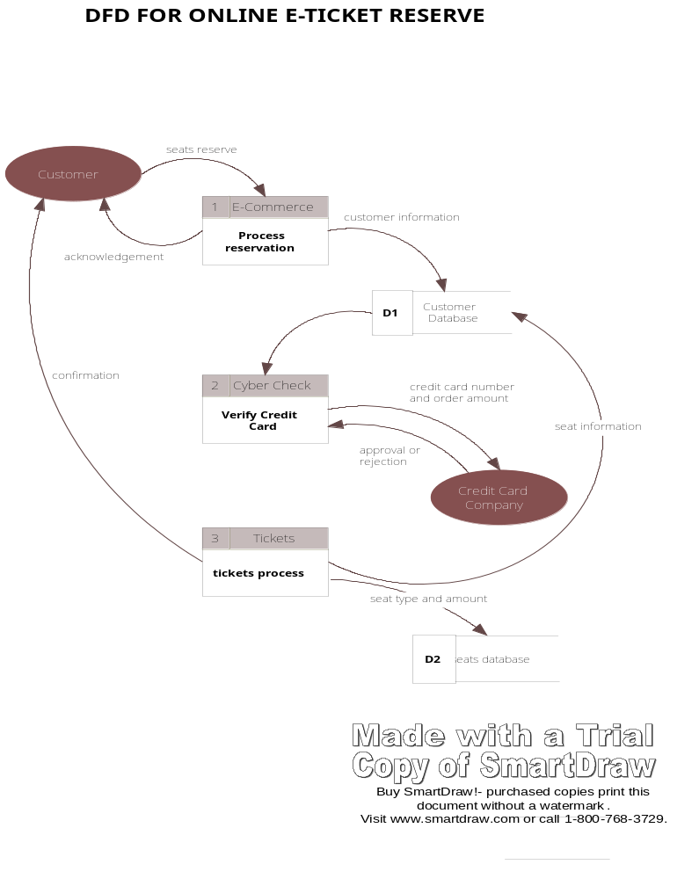

Fig. 2: Data Flow Diagram for Customer Process

3. USE CASES DIAGRAM:
Use cases are used during requirements elicitation and analysis to represent the functionality of the system. Use cases focus on the behavior of the system from the external point of view. The actors are outside the boundary of the system ,whereas the use cases are inside the boundary of the system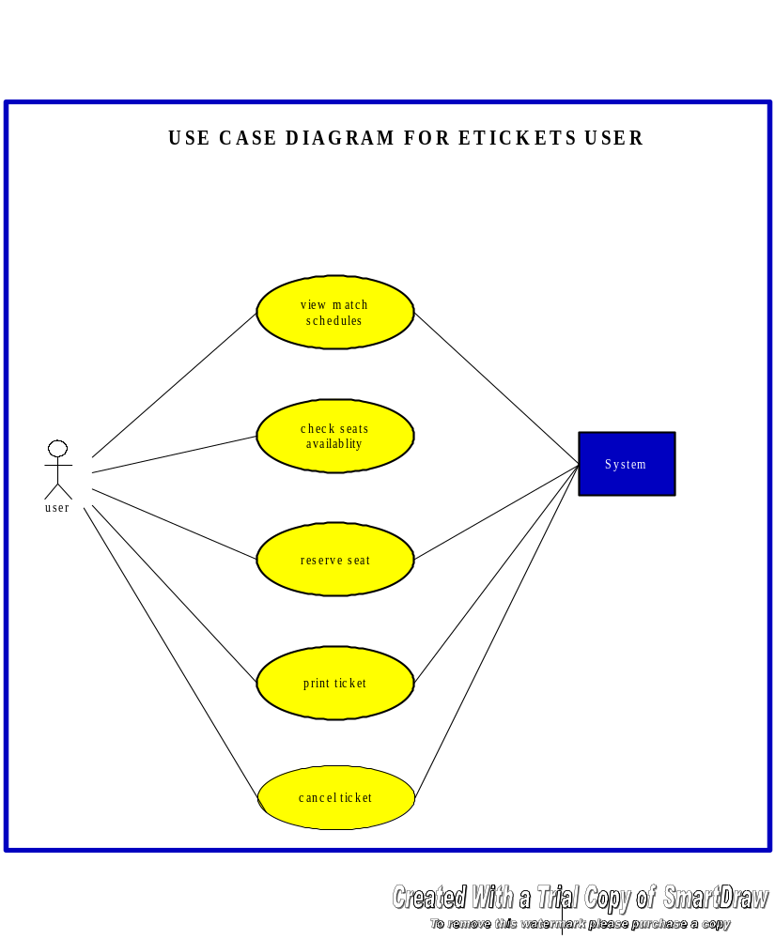
Fig : 3 Use Case Diagram User

4.SEQUENCE DIAGRAMS:

:Administrator
:login
check
:airports
:customers
1.enter
username and
password
2.check
details
3.provides
screen
4.add
,modify,delete sports
:
planes
5.allot
shedules
of matches
6.provide
seats registration to the users
7.mail
to the administrator to clarify doubts
8.mail
to the passengers to clear doubts
SEQUENCE DIAGRAM FOR ADMINISTRATOR

Buy SmartDraw
!
-

document without a watermark
.
Visit www
.
smartdraw
.
com or call
1
-
800
-
768
-
3729
.

FIG :4 SEQUENCE DIAGRAM FOR ADMINISTRATOR

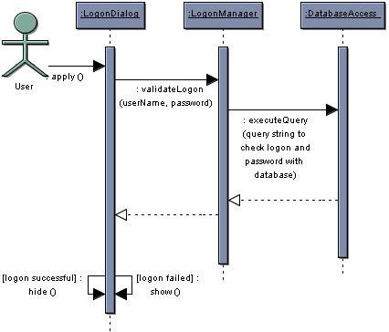

FIG :5 SEQUENCE DIAGRAM USER

COLLABORATION DIAGRAMS

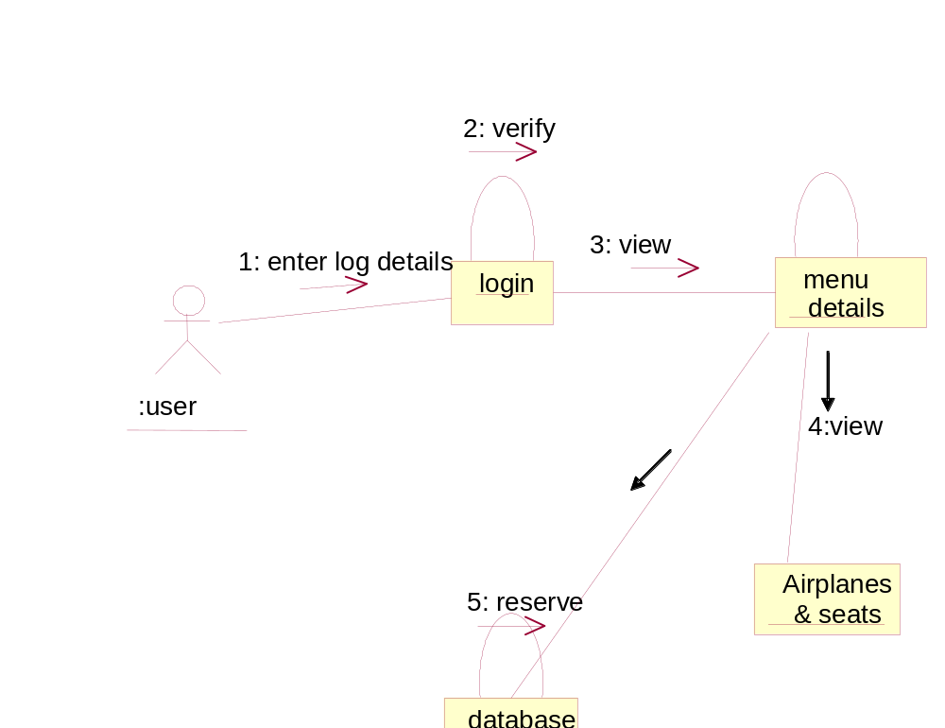

Fig 6. COLLABORATION DIAGRAM FOR USER

7. DATA DICTIONARY

Data dictionaries are integral component of structured analysis, since data flow diagrams by themselves do not fully describe the subject of the investigation. The data dictionary provides additional information about the system. A data dictionary is a catalog – repository provides additional information about the system.
A data dictionary is a catalog – repository of the elements in a system. In a data dictionary we will find a list of all elements composing the data flowing through the system. The major elements are data flows, data stores and process. The data dictionary stores details and descriptions of those elements.
Why is a data dictionary important?
Analysis use data dictionaries for five important reasons:
- To manage the details of the large system
- To communicate a common meaning for all system elements
- To document the features of the system

Table Definitions:

TABLE NAME : USERS

NAME | DATATYPE & SIZE | DESCRIPTION | CONSTRAINTS
USERID | VARCHAR(20) | USER ID | PRIMARY KEY
PASSWORD | VARCHAR(20) | PASSWORD
TYPS | VARCHAR(1) | TYPE OF USER

TABLE NAME : COSMOS

NAME | DATATYPE & SIZE | DESCRIPTION | CONSTRAINTS
USERID | VARCHAR(20) | USER ID | PRIMARY KEY
PASSWORD | VARCHAR(10) | PASSWORD | NOT NULL
FNAME | VARCHAR(20) | FATHER NAME
LNAME | VARCHAR(20) | LAST NAME
DOB | DATE | DATE OF BIRTH
SEX | VARCHAR(1) | SEX
EDUCATION | VARCHAR(20) | EDUCATION
OCCUPATION | VARCHAR(20) | OCCUPATION
NATIONALITY | VARCHAR(20) | NATIIONALITY
PADDRESS | VARCHAR(30) | PRESENT ADDRESS
PRADDRESS | VARCHAR(30) | PERMANENT ADDRESS
STATE | VARCHAR(20) | STATE
COUNTRY | VARCHAR(20) | COUNTRY
ZIP | NUMBER(10) | PIN CODE
PHONE | NUMBER(10) | PHONE
MOBILE | NUMBER(10) | MOBILE NUMER
OINFO | VARCHAR(60) | OTHER INFORMATION
CREDITCARDNAME | VARCHAR(20) | CREDIT CARD NAME
CREDITCARDNO | VARCHAR(15) | CREDIT CARD NUMBER
CPASSWORD | VARCHAR(15) | CREDIT CARD PASSWORD
PNR | NUMBER(10) | PNR NUMBER

TABLE NAME : AIRPORT

NAME | DATATYPE & SIZE | DESCRIPTION | CONSTRAINTS
AIRID | NUMBER(10) | AIRPORT ID | PRIMARY KEY
PLACENAME | VARCHAR(40) | PLACE NAME
STATE | VARCHAR(40) | STATE

TABLE NAME : DISTANCE
NAME | DATATYPE & SIZE | DESCRIPTION | CONSTRAINTS
FROMAIRID | NUMBER(10) | FROM AIRPORT ID | PRIMARY KEY
TOAIRID | NUMBER(30) | TO AIRPORT ID | PRIMARY KEY
NOKMS | NUMBER(10) | NUMBER OF KMS
TABLE NAME : FLIGHTDATABASE

NAME | DATATYPE & SIZE | DESCRIPTION | CONSTRAINTS
FLIGHTID | VARCHAR(10) | FLIGHT ID | PRIMARY KEY
FLIGHTNAME | VARCHAR(20) | NAME OF FLIGHT
CATEGORY | VARCHAR(10) | CATEGORY
STATUS | VARCHAR(1) | STATUS

TABLE NAME : FSCHEDULE

NAME | DATATYPE & SIZE | DESCRIPTION | CONSTRAINTS
FLIGHTID | VARCHAR(10) | FLIGHT ID | PRIMARY KEY
DOJ | DATE | DATE OF JOURNEY
TIMEIN | NUMBER(62) | TIME IN
TIMEOUT | NUMBER(62) | TIME OUT
FROMID | NUMBER(10) | FROM AIRPORT
TOID | NUMBER(10) | TO AIRPORT
ESEATS | NUMBER(10) | ECONOMY SEATS
EFARE | NUMBER(10) | ECONOMY FARE
BSEATS | NUMBER(10) | BUSINESS SEATS
BFARE | NUMBER(10) | BUSINESS FARE
EXSEATS | NUMBER(10) | EXECUTIVE SEATS
EXFARE | NUMBER(10) | EXECUTIVE FARE

CHAPTER - 2
PROJECT MODULES

PROJECT MODULES

The project is implemented in two major modules. Those are
- Administrator Module
- Customer Module

Administrator Module
The Administrator is a person who will create flights, airports, and schedules and also check the user logs and keep track of all the actions performed by them.

He is also able to add a new flight when ever needed, operating from a particular source to destination. Similarly, he is given a right to delete the flight when needed and modify the details when there is a change like increase in number of seats, day of flight cost of ticket, category, source, destination by logging on to flight information database.

Administrator Activities
- Airports Information
- Flights Information
- Flights Schedules
- Communication
  - Mail
  - Inbox
- Reports

Customer Module

This module provides activities like view of Flights, Airports, Flight Schedules, Seats in flights, Reservation, Cancellation, Postponement, Board Pass printing and Ticket Printing.
The Customer should be able to reserve a seat for a specific flight for a specific date. The reservation can be allowed only from 10 days prior to the date of departure. The customer can cancel an existing reservation provided with a decrease in some percentage of the amount paid by him (such as 50% return if cancelled on the due date of departure, else 25% return before the date). If the seats are filled up during the reservation process, then the customer is kept on to the waiting list, which in turn should automatically confirm.
The Payment process includes calculation of payable amount. Payment can be done either through credit card. If the customer reserves a ticket online he can pay the amount through credit card.

If the customer is a frequent flyer, he can register himself with an id and password. If the is a registered user he is provided with some offers like free club membership, concessions etc.

Customer Activities
- View of Domestic Fare
- View of Flights Information
- View of Flights Schedule
- Online Booking of Tickets
- Online Cancellation of Tickets
- Online Rescheduling of Tickets
- Board Pass Printing
- Ticket Printing
- Check of Seats Availability
- Mail
  - Inbox
  - Compose

The project is implemented through designing the screens using HTML, validations are done using JavaScript, the data is then processed using JSP and sent to ORACLE database using JDBC/ODBC connectivity. Also the data retrieved by the client is retrieved from the database using JSP and sent to the client. The screens that have restricted access are placed in the server side and the remaining screens appear in the client side.

CHAPTER - 3
CODING

SOURCE CODE

INDEX.HTML

<html>
<head>
<frameset rows="30%,60%" scroll=no border=0>
<frame src="head.html" scroll=no>
<frameset cols="20%,67%" scroll=no>
<frame name=menu src=menu.html scroll=no>
<frame src=blank.html name=blank scroll=no>
</frameset>
</frameset>
</head>
</html>
LOGIN.JSP

<STYLE TYPE="TEXT/CSS">
.LINKSLOGIN
{
FONT-SIZE: 10PX; COLOR: #000000; FONT-FAMILY: VERDANA, ARIAL, HELVETICA, SANS-SERIF; TEXT-DECORATION: NONE
}
.LINKSLOGIN:VISITED
{
FONT-SIZE: 10PX; COLOR: #000000; FONT-FAMILY: VERDANA, ARIAL, HELVETICA, SANS-SERIF; TEXT-DECORATION: NONE
}
.LINKSLOGIN:HOVER
{
FONT-SIZE: 10PX; COLOR: #D8510A; FONT-FAMILY: VERDANA, ARIAL, HELVETICA, SANS-SERIF; TEXT-DECORATION: NONE
}
.LINKSTOPMENU {
PADDING-LEFT: 3PX; FONT-SIZE: 10PX; COLOR: #000000; FONT-FAMILY: VERDANA, ARIAL, HELVETICA, SANS-SERIF; TEXT-DECORATION: NONE
}
.LINKSTOPMENU:VISITED
{
PADDING-LEFT: 3PX; FONT-SIZE: 10PX; COLOR: #000000; FONT-FAMILY: VERDANA, ARIAL, HELVETICA, SANS-SERIF; TEXT-DECORATION: NONE
}
.LINKSTOPMENU:HOVER
{
PADDING-LEFT: 3PX; FONT-SIZE: 10PX; COLOR: #000000; FONT-FAMILY: VERDANA, ARIAL, HELVETICA, SANS-SERIF; TEXT-DECORATION: NONE
}
TABLE
{
BACKGROUND-COLOR: #BBE9FF
}
INPUT
{
BORDER-RIGHT: #C3C3C3 1PX SOLID; BORDER-TOP: #C3C3C3 1PX SOLID; FONT-SIZE: 11PX; BORDER-LEFT: #C3C3C3 1PX SOLID; COLOR: #000000; BORDER-BOTTOM: #C3C3C3 1PX SOLID; FONT-FAMILY: VERDANA, ARIAL, HELVETICA, SANS-SERIF
}
.LINKSLOGIN
{
FONT-SIZE: 12PX; COLOR: #000000; FONT-FAMILY: VERDANA, ARIAL, HELVETICA, SANS-SERIF; TEXT-DECORATION: NONE
}
</STYLE>
<BODY LEFTMARGIN=0 TOPMARGIN=0 RIGHTMARGIN=0>
<center>
<IMG STYLE="POSITION:ABSOLUTE;TOP:0;LEFT:0;" WIDTH=594 HEIGHT=83 ALIGN=CENTER SRC=IMAGES\TOP.JPG>
<IMG HEIGHT=48 STYLE="POSITION:ABSOLUTE;TOP:0;LEFT:590;"
SRC="IMAGES/INTERNAL_TOP_02.JPG"
WIDTH=184 USEMAP=#MAP1 BORDER=0>>
<IMG HEIGHT=35 STYLE="POSITION:ABSOLUTE;TOP:47;LEFT:590;"
SRC="IMAGES/INTERNAL_TOP_04.JPG"
WIDTH=184 USEMAP=#MAP1 BORDER=0>
</CENTER>
<MAP NAME=MAP1><AREA SHAPE=RECT CLASS=LINKSTOPMENU
ALT=HOME COORDS=12,7,46,45
HREF=""><AREA SHAPE=RECT
TARGET=_BLANK COORDS=54,3,83,45
HREF="HOME.JSP" TARGET=_PARENT><AREA
SHAPE=RECT COORDS=91,5,121,46
HREF="SITE.JSP"><AREA
SHAPE=RECT COORDS=133,5,171,46
HREF=""></MAP>
<BR><BR><BR><BR>
<SCRIPT TYPE='TEXT/JAVASCRIPT' SRC='JS/EXMPLMENU_VAR.JS'></SCRIPT>
<SCRIPT TYPE='TEXT/JAVASCRIPT' SRC='JS/MENU_COM.JS'></SCRIPT>
<FORM NAME=LOGIN METHOD=POST ACTION=LOGIN.JSP>
<BR>
<TABLE STYLE="POSITION:ABSOLUTE;LEFT:550;TOP:81;" BORDER=0 ALIGN=LEFT>
<TR>
<TD>&NBSP;&NBSP;&NBSP;&NBSP;&NBSP;&NBSP;&NBSP;&NBSP;&NBSP;<IMG SRC=IMAGES\COSMOS_TITLE.JPG ></TD><TD></TD>
</TR><TR><TD><HR></TD> </TR><TR>
<TD><FONT FACE=VERDANA SIZE=2><B>LOGIN ID&NBSP;&NBSP;&NBSP;&NBSP;&NBSP; </B></FONT>
<INPUT TYPE=TEXT NAME=LOGINID></TD><TD></TD>
</TR><TR><TD><FONT FACE=VERDANA SIZE=2><B>PASSSWORD </B></FONT>
<INPUT TYPE=PASSWORD NAME=PASS></TD><TD></TD>
</TR><TR>
<TD>&NBSP;&NBSP;&NBSP;&NBSP;&NBSP;&NBSP;&NBSP;&NBSP;&NBSP;&NBSP;&NBSP;&NBSP;&NBSP;&NBSP;&NBSP;&NBSP;&NBSP;&NBSP;&NBSP;&NBSP;&NBSP;
<INPUT TYPE=SUBMIT VALUE=LOGIN></A></TD><TD></TD></TR>
<TR><TD><HR></TD> </TR><TR><TD>
&NBSP;&NBSP;&NBSP;&NBSP;&NBSP;&NBSP;&NBSP;&NBSP;&NBSP;&NBSP;<IMG SRC=IMAGES\BULLET_SMALL.JPG>
<A CLASS="LINKSLOGIN" HREF="REGIS.JSP">NEW USER ? REGISTER </A>
</TD></TR><TR><TD>&NBSP;&NBSP;&NBSP;&NBSP;&NBSP;&NBSP;&NBSP;&NBSP;&NBSP;&NBSP;<IMG SRC=IMAGES\BULLET_SMALL.JPG>
<A CLASS="LINKSLOGIN" HREF="NEWPASS.HTML">FORGOT PASSWORD</A>
</TD></TR><TR><TD><HR></TD> </TR><TR>
<TD> <MARQUEE DIRECTION=UP><FONT FACE=VERDANA SIZE=2 COLOR=GREEN><B> BHARAT AIRWAYS PACKAGES <BR>HOLIDAY PACKAGES<BR>FAMILY PACKAGES <BR> GROUP PACKAGES</FONT> </MARQUEE> </TD></B>
</TR><TR><TD><HR></TD> </TR></TABLE>
<TABLE STYLE="POSITION:ABSOLUTE;LEFT:0;TOP:81;" BORDER=0 ALIGN=LEFT>
<TR><TD><HR></TD> </TR><TR><TD>
&NBSP;&NBSP;&NBSP;&NBSP;<IMG SRC=IMAGES\BULLET_SMALL.JPG>
<A CLASS="LINKSLOGIN" HREF="HOME.JSP" ONCLICK="ALERT('PLZ LOGIN FOR MORE DETAILS')">DOMESTIC FARES</A>
</TD></TR><TR><TD>&NBSP;&NBSP;&NBSP;&NBSP;<IMG SRC=IMAGES\BULLET_SMALL.JPG>
<A CLASS="LINKSLOGIN" HREF="HOME.JSP" ONCLICK="ALERT('PLZ LOGIN FOR MORE DETAILS')">ONLINE BOOKING</A>
</TD></TR><TR><TD>&NBSP;&NBSP;&NBSP;&NBSP;<IMG SRC=IMAGES\BULLET_SMALL.JPG>
<A CLASS="LINKSLOGIN" HREF="HOME.JSP" ONCLICK="ALERT('PLZ LOGIN FOR MORE DETAILS')">VIEW SCHEDULES</A>
</TD></TR><TR><TD>&NBSP;&NBSP;&NBSP;&NBSP;<IMG SRC=IMAGES\BULLET_SMALL.JPG>
<A CLASS="LINKSLOGIN" HREF="HOME.JSP" ONCLICK="ALERT('PLZ LOGIN FOR MORE DETAILS')">RESCHEDULE BOOKING</A>
</TD></TR><TR><TD>&NBSP;&NBSP;&NBSP;&NBSP;<IMG SRC=IMAGES\BULLET_SMALL.JPG>
<A CLASS="LINKSLOGIN" HREF="HOME.JSP" ONCLICK="ALERT('PLZ LOGIN FOR MORE DETAILS')">SEAT AVAILABILITY</A>
</TD></TR><TR><TD>&NBSP;&NBSP;&NBSP;&NBSP;<IMG SRC=IMAGES\BULLET_SMALL.JPG>
<A CLASS="LINKSLOGIN" HREF="HOME.JSP" ONCLICK="ALERT('PLZ LOGIN FOR MORE DETAILS')">CANCEL BOOKING</A>
</TD></TR><TR><TD>&NBSP;&NBSP;&NBSP;&NBSP;<IMG SRC=IMAGES\BULLET_SMALL.JPG>
<A CLASS="LINKSLOGIN" HREF="HOME.JSP" ONCLICK="ALERT('PLZ LOGIN FOR MORE DETAILS')">FLIGHT INFORMATION</A>
</TD></TR><TR><TD>&NBSP;&NBSP;&NBSP;&NBSP;<IMG SRC=IMAGES\BULLET_SMALL.JPG>
<A CLASS="LINKSLOGIN" HREF="CONTACT.JSP">CONTACT US</A>
</TD></TR><TR><TD>&NBSP;&NBSP;&NBSP;&NBSP;<IMG SRC=IMAGES\BULLET_SMALL.JPG>
<A CLASS="LINKSLOGIN" HREF="HOME.JSP" ONCLICK="ALERT('PLZ LOGIN FOR MORE DETAILS')">FEEDBACK</A>
</TABLE>
<IMG SRC=IMAGES/13.GIF STYLE="POSITION:ABSOLUTE;TOP:80;LEFT:155;" WIDTH=394 HEIGHT=433 ALIGN=CENTER >
</BODY>
</HTML>

CHAPTER - 4
TESTING AND DEBUGGING

Introduction:

Testing is one of the most important phases in the software development activity. In software development life cycle (SDLC), the main aim of testing process is the quality; the developed software is tested against attaining the required functionality and performance.

During the testing process the software is worked with some particular test cases and the output of the test cases are analyzed whether the software is working according to the expectations or not.

The success of the testing process in determining the errors is mostly depends upon the test case criteria, for testing any software we need to have a description of the expected behavior of the system and method of determining whether the observed behavior confirmed to the expected behavior.

The system was tested in the following methods:
- Unit Testing
- Integration Testing
- System Testing

UNIT TESTING

Unit testing was performed on low-level modules, proceeding one at a time. Bottom-up testing was performed on each module. After the lower level modules were tested, the modules that in the next higher level those make use of the lower modules were tested.

INTEGRATION TESTING

Integration testing was preformed for constructing the program structure, while at the same time conducting tests to uncover errors associated with interfacing. As the system consists of the number of modules the interface to be tested was between the edges of the two modules.

They are two different approaches in integration test.
1. Top-down Integration
2. Bottom-up Integration

Top-down Integration testing is used, which is an incremental approach to construction of program structure. Modules are integrated by moving downward through the control Hierarchy, beginning with the main control module. Module subordinate to the main control module are incorporated into the structure in either the Depth first or Breadth first manner.

In this project we are using the Depth first method for testing and executing the modules.

SYSTEM TESTING:

System testing has been conducted to test the integration of each module in the system .It is used to find discrepancies between the system and its original objective. It is found that there is an agreement between current specifications and system documentation.

Software Testing is carried out in three steps

The first step includes unit testing where in each module is tested to provide his correctness, validity and also determine any missing operations. Errors are noted down and corrected immediately. Unit testing is the import and major part of the project. So errors are rectified easily in particular module and program clarity is increased. In this project entire system is divided into several modules and is developed individually. So unit testing is conducted to individual modules.

The second step includes integration testing. It need not be the case, the software whose modules when run individually and showing perfect results, will also show perfect results when run as a whole. The individual modules are clipped under this major module and tested again and the results are verified.
The final step involves validation and testing which determines the software functions as the user expected. Here also there may be some modifications. In the completion of the project it is satisfied fully by the user.

White Box Testing:

Basis Path Testing:

The Basis Path method enables the test case designer to derive a logical complexity measure of a procedural design and use this measure as a guide for defining a basis set of execution paths. Test cases derived to exercise the basis set are guaranteed to execute every statement in the program at least one time during testing.

- Flow Graph Notation:

The flow graph depicts logical control flow using the notations. Each structured construct has a corresponding flow graph symbol. Areas bounded by edges and nodes are called Regions. Each node that contains a condition is called a Predicate Node (P).

- Cyclomatic Complexity:

Cyclomatic Complexity is software metric that provides a quantitative measure of the logical complexity of a program. It has a foundation in graph theory and is computed in one of three ways:
- The number of regions corresponds to the Cyclomatic Complexity is 2.
- Cyclomatic Complexity, V(G) for a flow graph G, is defined as

V(G)= E – N + 2

Where E is the number of flow graph edges, and N is the number of flow graph nodes.

V(G) = 6-6+2

= 2
- V(G) = P + 1

= 1 + 1

= 2

Start
Authentication and connection
Display Data list
Manage Databases
Sub Items
End
Y
N
security

1
6
P1
2
4
3
5
R1
R2

Verification and validation:

Verification refers to set of activities that ensure that software correctly implements a specific function.

Validation refers to different set of activities that ensure that the software has been built is traceable to customer requirements.

Validation Testing:

It is done by executing the application with a set of inputs, for which the manual result is ready. The applications output and the required output is tallied with the manual one.

- Recovery Testing:

It is a system test that forces the software to fail in a variety of ways and verifies that recovery is properly performed. This application requires human intervention.

- Security Testing:

It attempts of verify that protecting mechanisms built into a system will infect protect it from improper penetration using the following measures.

- It is verified that, by giving an incorrect password will deny the accessing of server desktop or not.

- By maintaining session we can avoid access to data of the previous user by the new user.

- Trying to edit the entries where permission is not granted.

3. Performance Testing:

In this the runtime performance of software is tested within the context of integrated system.

In addition the following test strategies are performed during the test period.

- Application function Test:

The functionality of client application is tested by using the methods of software testing strategies, unit testing, validation and integration testing.

- Server Test:

The coordination and data manage function of the server are tested. Server performance that is overall response time and data through put is also considered.

- Database Test:
The accuracy and integrity of data stored by the server is tested. Transactions posted by client applications are examined to ensure the data are properly stored, updated and retrieved.

- Transaction Testing:

A series of test are made to ensure that each class of transaction is processed according to the requirements.

- Acceptance Testing:

When the user finds no major problems with the accuracy, the system passes through the final acceptance test. This confirms if it meets the original goals, objectives and requirements established during analysis. If the system fulfills all the requirements it is finally acceptable and ready for operation.

CHAPTER – 5
SCREENS

SCREEN SHOTS

Home Page

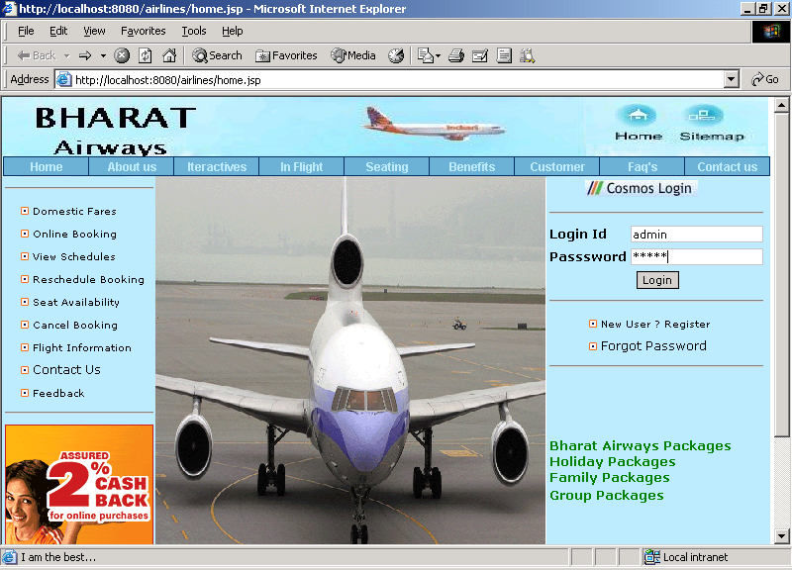

ADMIN MENU

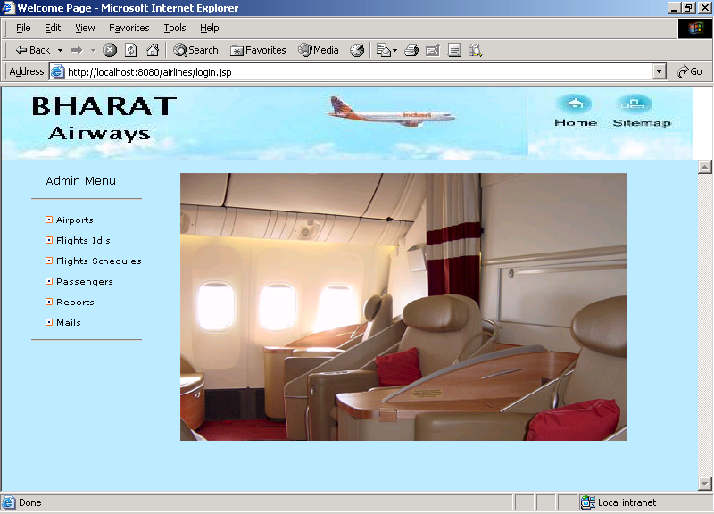

FLIGHT INFORMATION

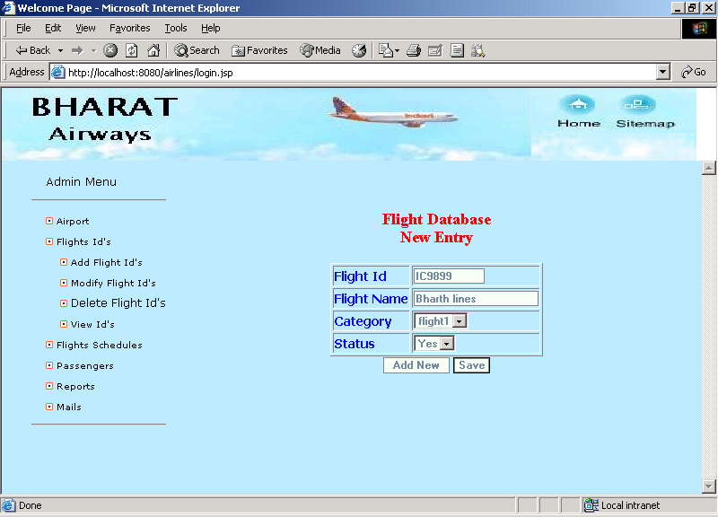

FLIGHT SCHEDULES

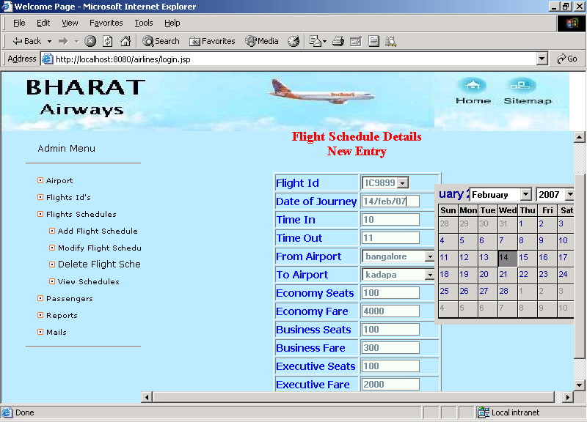

ADMIN INBOX

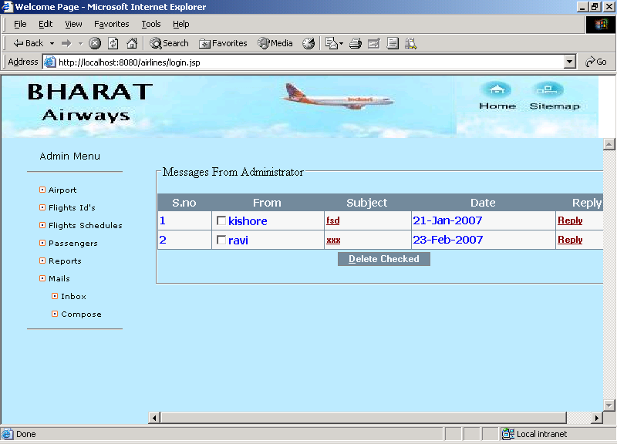

ADMIN MESSAGE

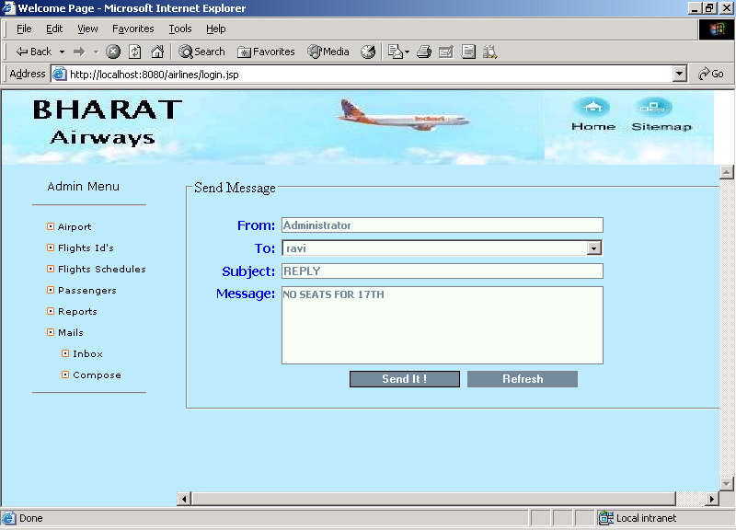

REGISTERATION FORM

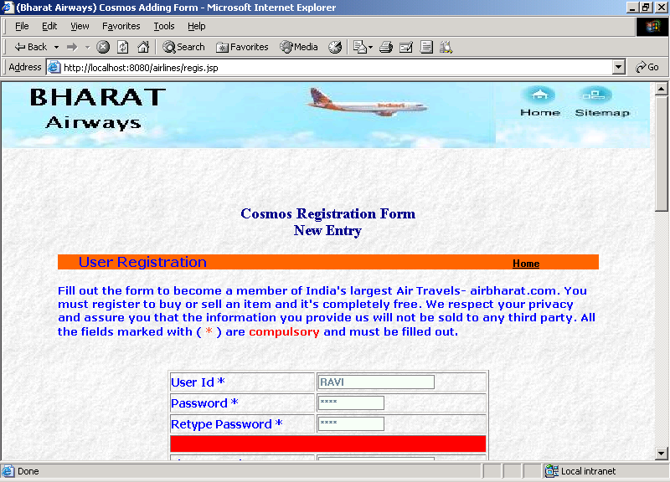

CUSTOMER MENU

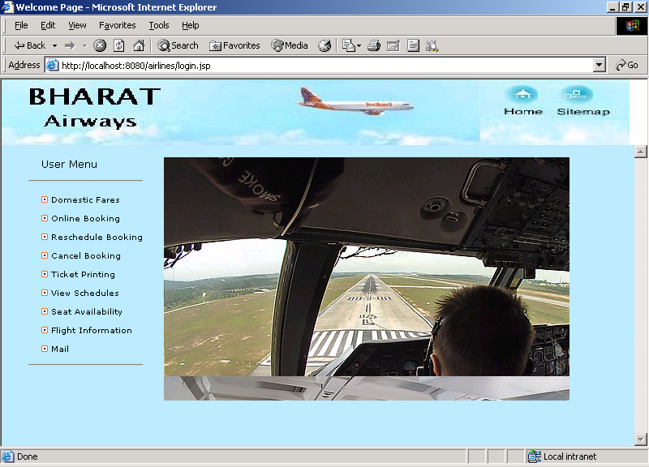

DOMESTIC FARES

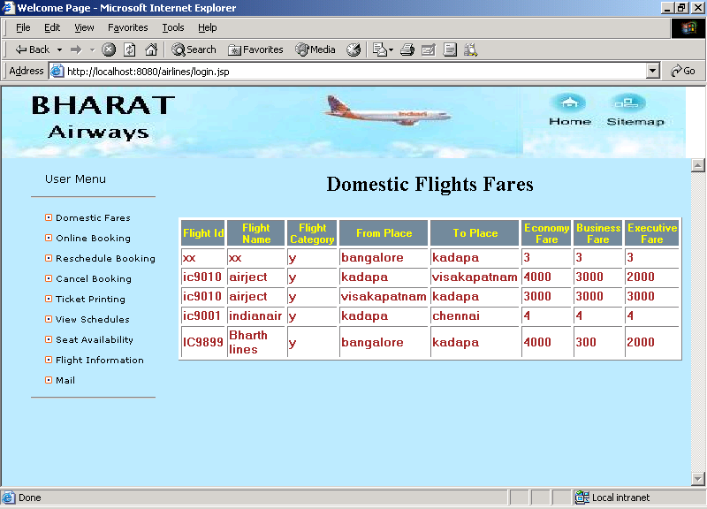
ONLINE BOOKING
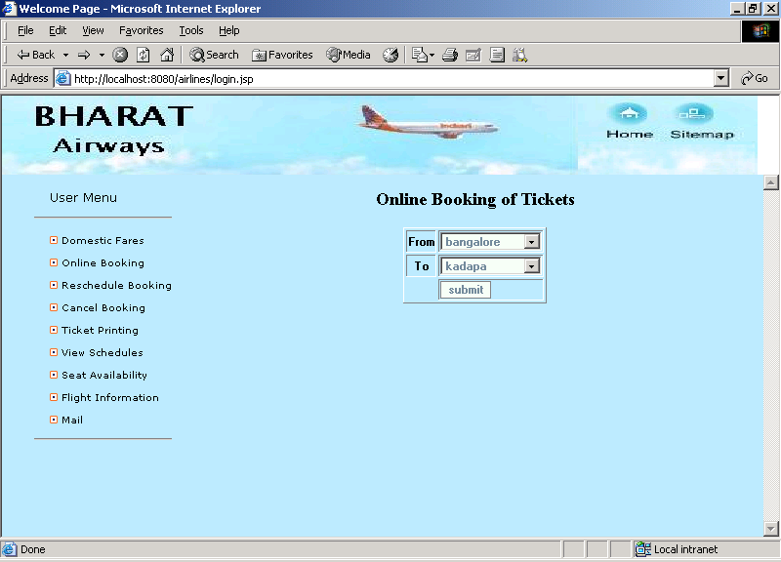
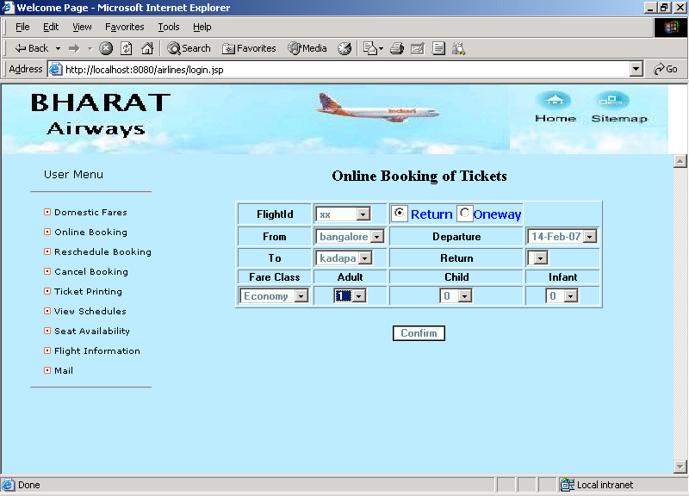
BOARDING PASS & TICKET PRINTING
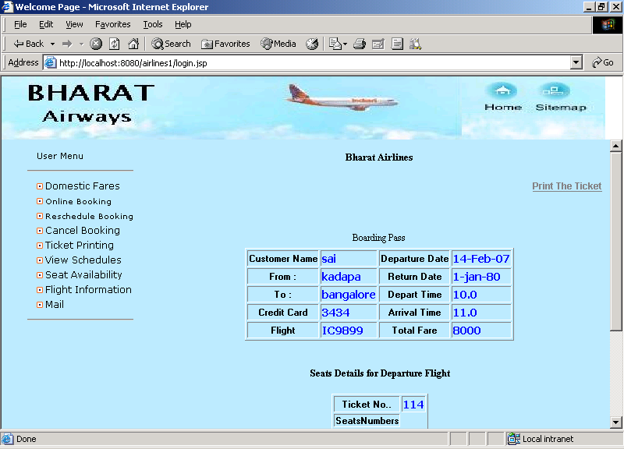
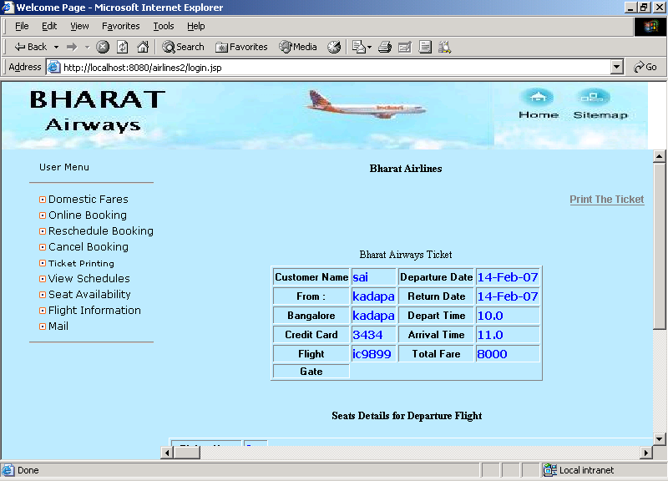

VIEW SCHEDULES

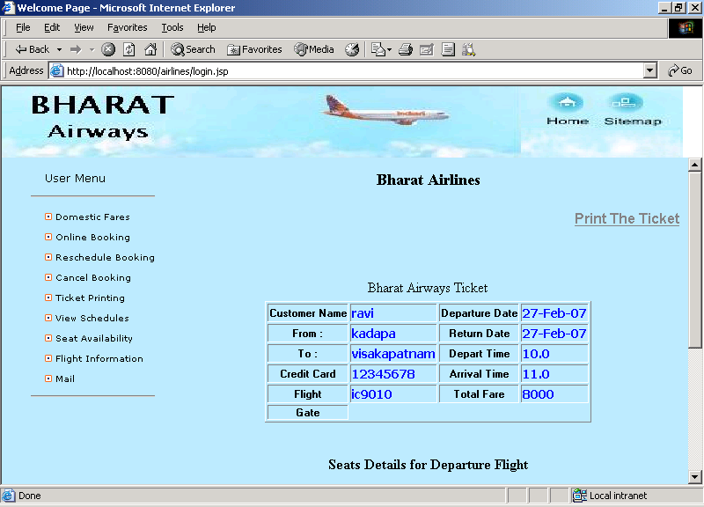
REPORTS

FLIGHT DATABASE

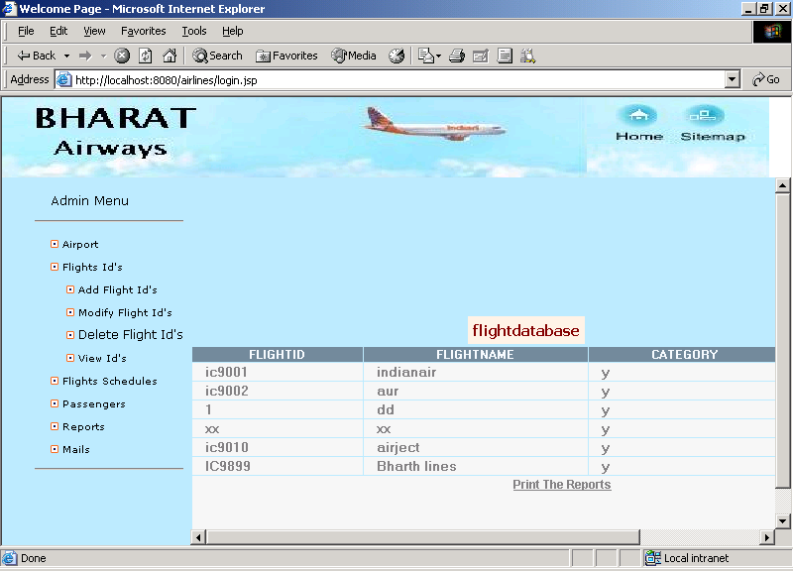

SCHEDULES INFORMATION

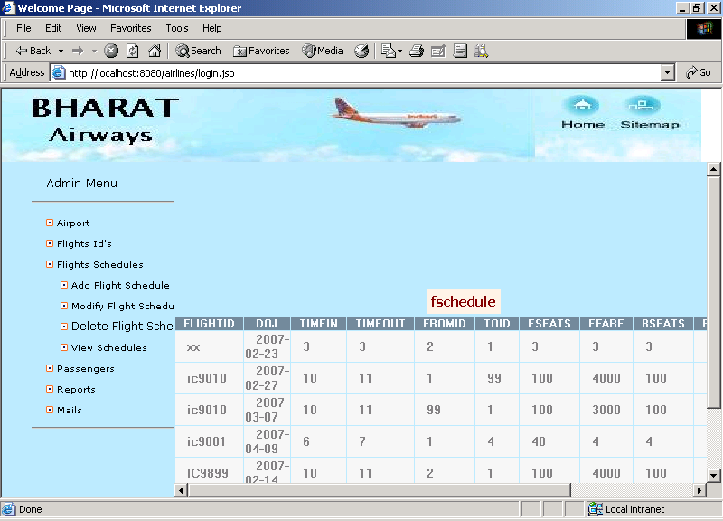

LIST OF PASSENGERS

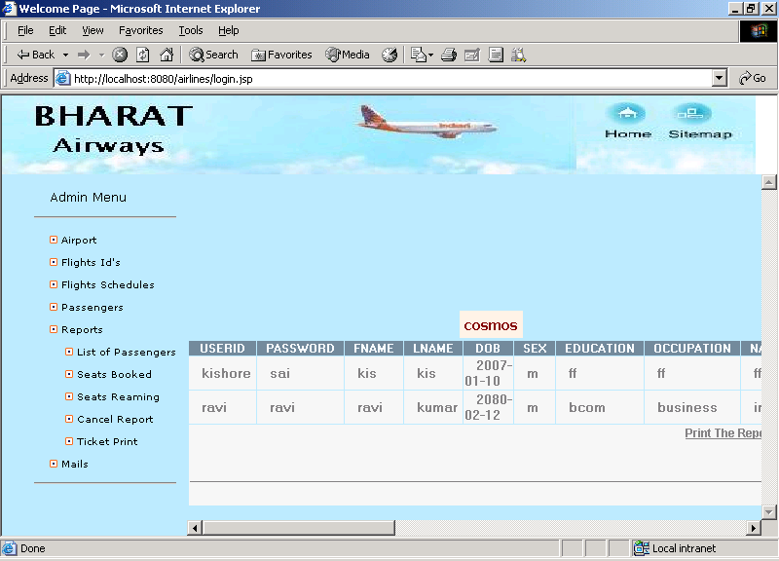
SEATS BOOKED
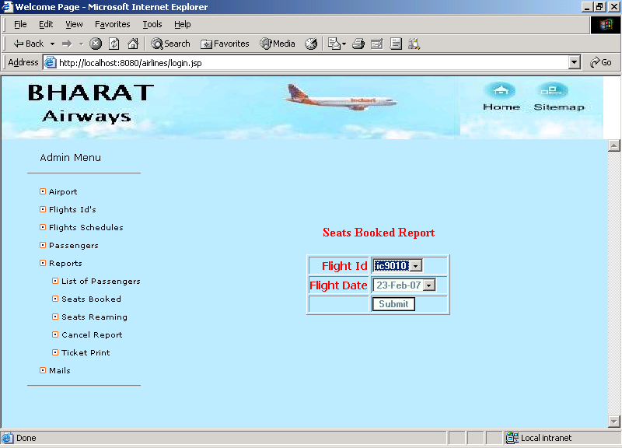
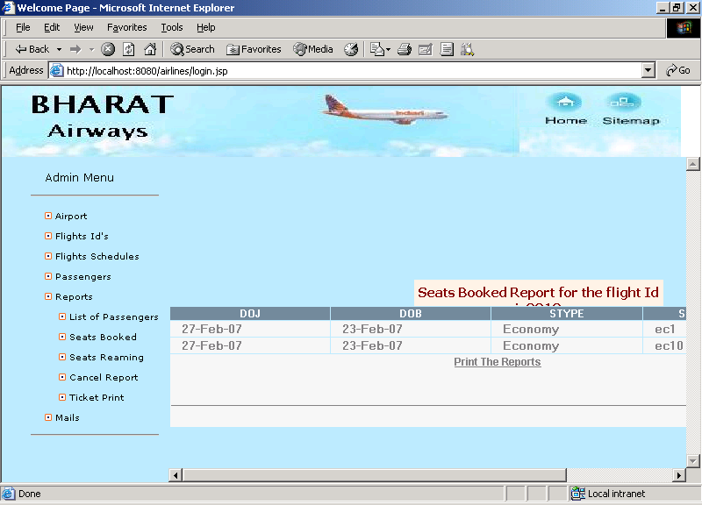

SEATS REMAINING
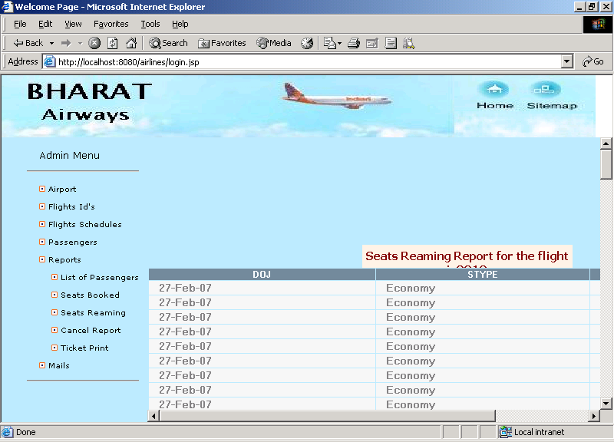

CHAPTER – 6
TECHNOLOGIES

OVERVIEW OF TECHNOLOGIES

1. JAVA
The Internet helped catapult Java to the forefront of programming and Java in turn has had a profound effect on the Internet. The reason is simple: Java expands the universe of objects that can move about freely in cyberspace. In a network, there are two broad categories of objects transmitted between the Server and your Personal Computer: passive information and dynamic, active programs like an object that can be transmitted to your computer, which is a dynamic, self-executing program. Such a program would be an active agent ton the client computer, yet the server would initiate it. As desirable as dynamic, networked programs are, they also present serious problems in the areas of security and portability. Prior to Java cyberspace was effectively closed to half the entities that now live there. Java addresses these concerns and doing so, has opened the door to an exiting a new form of program.

JAVA SERVER PAGE (JSP):
Java Server Pages is a simple, yet powerful technology for creating and maintaining dynamic-content web pages. Based on the Java programming language, Java Server Pages offers proven portability, open standards, and a mature re-usable component model.
PORTABILITY:
Java Server Pages files can be run on any web server or web-enabled application server that provides support for them. Dubbed the JSP engine, this support involves recognition, translation and management of the Java Server Pages lifecycle and its interaction with associated components.

COMPOSITION:
It was mentioned earlier that the Java Server Pages architecture could include reusable Java components. The architecture also allows for the embedding of a scripting language directly into the Java Server Pages file. The components current supported include Java Beans and Serves. As the default scripting language, Java Server Pages use the Java Programming language. This means that scripting on the server side can take advantage of the full set of capabilities that the Java programming language offers.

PROCESSING:

A Java Server Pages file is essentially an HTML document with JSP scripting or tags. It may have associated components in the form of class, .jar, or .ser files- -or it may not. The use of components is not required.
The Java Server Pages file has a .jsp extension to identify it to the server as a Java Server Pages file. Before the page is served, the Java Server Pages syntax is parsed and processed into a servlet on the server side. The servlet that is generated, outputs real content in straight HTML for responding to the customer. Because it is standard HTML, the dynamically generated response looks no different to the customer browser than a static response.

2. HTML

Hypertext Markup Language (HTML), the languages of the World Wide Web (WWW), allows users to produces Web pages that include text, graphics and pointer to other Web pages (Hyperlinks).

HTML is not a programming language but it is an application of ISO Standard 8879, SGML (Standard Generalized Markup Language), but specialized to hypertext and adapted to the Web. The idea behind Hypertext is that instead of reading text in rigid linear structure, we can easily jump from one point to another point. We can navigate through the information based on our interest and preference. A markup language is simply a series of elements, each delimited with special characters, that define how text or other items enclosed within the elements should be displayed. Hyperlinks are underlined or emphasized works that load to other documents or some portions of the same document.

HTML can be used to display any type of document on the host computer, which can be geographically at a different location. It is a versatile language and can be used on any platform or desktop.

HTML provides tags (special codes) to make the document look attractive. HTML tags are not case-sensitive. Using graphics, fonts, different sizes, color, etc., can enhance the presentation of the document. Anything that is not a tag is part of the document itself.

Basic HTML Tags :
<!-- --> Specifies comments
<A>……….</A> Creates hypertext links
<B>……….</B> Formats text as bold
<BIG>……….</BIG> Formats text in large font.
<BODY>…</BODY> Contains all tags and text in the HTML document
<CENTER>...</CENTER> Creates text
<DD>…</DD> Definition of a term
<DL>...</DL> Creates definition list
<FONT>…</FONT> Formats text with a particular font
<FORM>...</FORM> Encloses a fill-out form
<FRAME>...</FRAME> Defines a particular frame in a set of frames
<H#>…</H#> Creates headings of different levels
<HEAD>...</HEAD> Contains tags that specify information about a document
<HR>...</HR> Creates a horizontal rule
<HTML>…</HTML> Contains all other HTML tags
<META>...</META> Provides meta-information about a document
<SCRIPT>…</SCRIPT> Contains client-side or server-side script

ADVANTAGES
- A HTML document is small and hence easy to send over the net. It is small because it does not include formatted information.
- HTML is platform independent.
- HTML tags are not case-sensitive.

3. INTRODUCTION TO ORACLE:

ORACLE is a comprehensive operating environment that packs the power of a mainframe system into user microcomputer. It provides a set of functional programs that user can use as tools to build structures and perform tasks. Because applications developed on oracle are completely portable to environment and then move it into a multi user platform. Users do not have to be an expert to appreciate ORACLE, but the better user understands the programmer, the more productivity and creativity you will use the tools it provides.

STRUCTURED QUERY LANGUAGE (SQL)
SQL is an inter-active language used to query the database and access data in database. SQL has the following features:
- It is a unified language.
- It is a common language for relational database
- It is a non-procedural language.

CHAPTER – 7
CONCLUSION

CONCLUSION AND FUTURE SCOPE

The need for the airlines computerize processing and servicing the customer request through automated modules is most necessary and now inevitable.

This is the application developed for doing the online reservations process on the Internet. In addition to this we also provided communication between customers and administrator. The project is helpful for the customer to book their tickets online with any mediators.

11.2 SCOPE OF FUTURE ENHANCEMENT:
- The security features can also be extended to next higher level
- Providing online reservations through Mobile phone

CHAPTER - 8
BIBLIOGRAPHY

BIBLIOGRAPHY

- George Koch, Kevin Loney, “Oracle – The Complete Reference”, Tata McGraw Hill, Third Edition, 2001.
- Henry F Korth, S. Sudharshan, “Database System Concepts” McGraw – Hill International Editions, Fourth Edition, 2002.
- Herbert Schildt & Patrick Naughton, “Java2 Complete Reference”, Tmh 3/e, 1999.
- James Jawroski, “Mastering Java Script”, Tmh 3/e, 2000.
- Roger S Pressman, “Software Engineering – A Practitioner’s approach” McGraw – Hill International Editions, Fifth Edition, 2001.

WEB REFERENCES
www.w3schools.org
www.java2s.com
www.javahelp.com

